SPECIALIST MATHEMATICS
UNITS 3 & TRIAL EXAMINATION 1
SOLUTIONS
2024

Question 1 (3 marks)

Evaluate using integration by parts.
The integration by parts formula is given on the formula sheet: .
Let and let .
and .

(1 mark)
(1 mark)
(1 mark)

Question 2 (3 marks)

,
(1 mark – simplify cot⁴(x) or re-write cos(2x))

Let
(1 mark – recognise quadratic = 0)

Given (quadrant 2)
(1 mark)

Question 3 (4 marks)

Let I be the normal random variable for the volume (mL) of ice-cream dispensed.
Let T be the normal random variable for the volume (mL) of chocolate topping dispensed.

a. Let , where V is the random variable for the volume (mL) of ice-cream and chocolate topping dispensed.

since I and T are independent random variables
(1 mark – either E(I + T) or Var(I + T) correct)

= since
(correct to 3 decimal places) (1 mark)

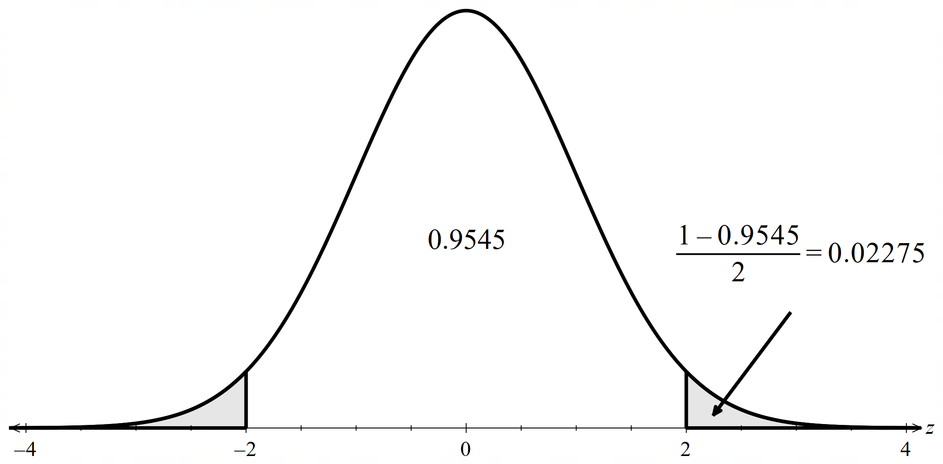

b. Cost =
(note: multiply by to account for conversion from mL to L)

(1 mark)
(nearest cent) (1 mark)

Question 4 (3 marks)

Let be the proposition that for all integers .

Step 1 Show is true.
which is true. (1 mark)

Step 2 Assume that is true for , .

Step 3 Prove that true implies that is true.

(1 mark)

It follows that true implies that is true.
Using the principle of mathematical induction, it therefore follows that P(n) is true for all integers . (1 mark)

Question 5 (3 marks)

a. The scalar resolute of in the direction of is .

and

(1 mark)

b. Let be the vector resolute of in the direction of .

= = = (1 mark)

Let be the vector resolute of that is perpendicular to .

Then
vector resolute of that is perpendicular to is

(1 mark)

Alternatively, you can use and scalar resolute of in the direction of
= to determine that .

Question 6 (6 marks)

a.

Using implicit differentiation,

(1 mark)

Method 1 – Rearrange for first

Sub in the point ,

(1 mark)

Method 2 – Substitute in the point into .

b. Using formula sheet, Surface Area
(1 mark – either derivative correct)

(1 mark – get to point of simplifying cos²(t) + sin²(t))
since

Given symmetry of graph, it is easier to use domain as this gives and (therefore ) and multiply by 2.

(1 mark)

Let
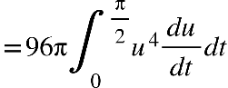

units² (1 mark)

Question 7 (3 marks)

Let , .

(1 mark)

Equating real parts: …… (1)
Equating imaginary parts: ……. (2)

From (2),
or

- Substitute into (1)

Check discriminant,
no real solution for x therefore y = 0 is rejected.
(1 mark – determine only one solution for x)

- Substitute into (1)

, (1 mark)

Question 8 (4 marks)

(1 mark – attempt to separate variables)
(1 mark)

Method 1 – rearrange the constant

where

Substitute in :

(1 mark – attempt to find A)

Therefore
(1 mark)

Method 2 – find the +c first

Given ,

(1 mark – attempt to find +c)

Using the given condition of , leads us to reject the negative answer.

(1 mark)

Question 9 (4 marks)

a. By inspection, is a vector in the direction of the line and is a vector in the direction of the line .

By definition, the angle between two lines is equal to the angle between these two vectors and is found using the dot product.

Using the dot product, ,
(1 mark)
(1 mark)

Since the ‘squaring’ process can introduce extraneous solutions, it should be checked that satisfies the original equation (which it does).

b. A normal to the plane is a vector normal to the direction of each line, that is, normal to the vectors and .

The cross product is used to determine this normal vector and hence, the equation of the plane.

Using the formula sheet for vectors and , .

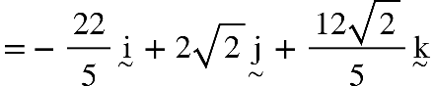

, is the equation of the plane. (1 mark)

Substitute in a point on the plane e.g. (which was found when for line ).

(Another point that could be used as an example is found when for ).

is the equation of the plane. (1 mark)
(alternatives include or )

Question 10 (7 marks)

a.

(1 mark – attempt quotient rule and simplification)

Stationary point occurs when

stationary point is at . (1 mark – show that)

b.

A condition for a point of inflection to occur is that

(1 mark – show that)

A second condition for a point of inflection to occur is that there must be a change in concavity (that is, a change in sign of ).

x | 0 |  | 1
 |  | 0

(1 mark – show sign change)

c.
- Stationary point given at

- y-intercept:

- x-intercepts:

- asymptotes: vertical asymptote

horizontal asymptote

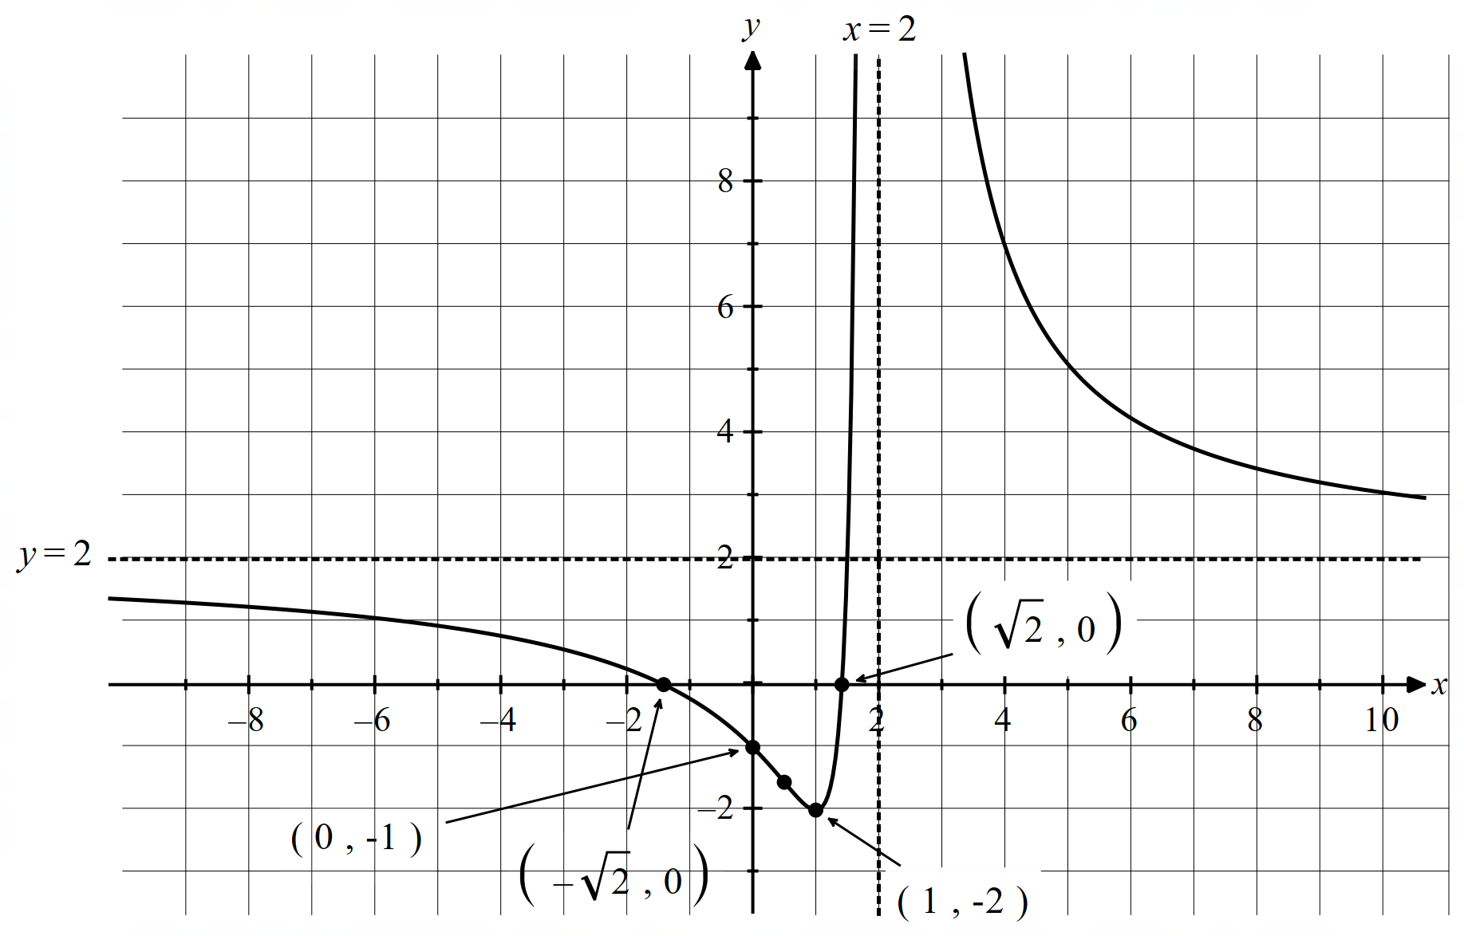

(1 mark – two asymptotes with their equations)
(1 mark – correct shape including point of inflection shape indicated)
(1 mark – correct y-intercept, x-intercepts and stationary point)

